Jacksonville Weavers’ Guild
Presents our 2020 Workshop with
Dottie Weir
LOOM CONTROLLED WOVEN SHIBORI

“Using an ancient technique called ‘Shibori,’ we will create a one-of-a-kind, permanently pleated scarf. Learn how to weave woven weft Shibori, dye paint with fiber reactive dyes, then permanently pleat your piece.”
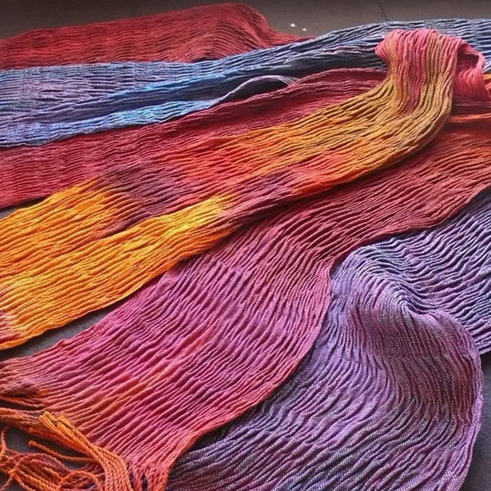

Dates: Friday, Saturday & Sunday – February 7, 8 & 9, 2020 9:00-4:00
Place: Ft. Caroline Community Center, 4131 Ferber Rd. Jacksonville, FL 32277

LOOM CONTROLLED WOVEN SHIBORI

“Woven shibori uses the loom to make fabric as well as to make a resist for dyeing or shaping. It is a true joining together of weaving and surface design. Participants will use a variety of woven structures to weave their scarves. After the cloth is woven, we will explore ways in which the woven image can be applied to the cloth by dyeing and shaping. Woven shibori introduces the hand weaver to unlimited possibilities for designing. Participants will learn how to use fiber reactive and vat dyes.” D.W.

Preparation:
Participants must bring a loom, 4 or more shafts, dressed prior to the first day with enough warp yarn for at least one scarf or more, if wanted, as we will be weaving several samples and experimenting with different dye techniques. Threading drafts and yarn requirements will be provided closer to the actual workshop date.
Related materials and equipment for weaving include a bench or chair; two shuttles and two bobbins for the weaving portion of the class, tapestry and sewing needles with a large eye, scissors and tape measure.
For the dyeing portion: bring a dust mask, gloves, sponge brushes and wear old clothes. The dyeing class isn’t recommended for pregnant women.

Cost for the 3 Day Workshop:

Guild Members - $150
Non-guild Members - $175
(Plus $10 Materials Fee for the instructor)

This workshop is limited to 15 participants, so register early to reserve your space. A non-refundable deposit of $50 is required at registration and the final payment is due by
January 15, 2020. Please make your check out to Jax Weavers’ Guild. And
send with your deposit to Ann Wingate, 1124 Salt Creek Dr, Ponte Vedra Beach, FL 32082.

JACKSONVILLE WEAVERS’ GUILD

Registration: “Loom Controlled Woven Shibori Workshop”
with Dottie Weir

Dates: February 7, 8 & 9, 2020

Name: _________________________________________________________

Address: _________________________________________________________

_________________________________________________________

Phone: _________________________________________________________

e-mail: _________________________________________________________

Please make your check to Jax Weavers’ Guild and send with your deposit to:
Ann Wingate, 1124 Salt Creek Drive, Ponte Vedra Beach, FL 32082

